
Machine Translated by Google
˜
´
´
´
alert, security in the
´
entertainment.
between he ages of eight and thir een have access to a mobile

CyberKids: video game for raising cyber security awareness in children

Juan Perez

Engineering Faculty
Andres Bello University

Vina del Mar, Chile

j.perezveas@uandresbello.edu
Roman Torres

Engineering Faculty
Andres Bello University

Vina del Mar, Chile
romina.torres@unab.cl

Sven von Brand

Engineering Faculty
Andres Bello University

Vina del Mar, Chile

svbrand@gmail.com

Abstract—In most countries, a large percentage of children two, good results are described on the 200 students
device atthome, where monitoringtand supervision by a trusted intervened [3]. A systematic study on serious games in cybersecurity categorizes them into being adult is not enough, so statistics on children victimized by
bullying and damage to the integrity of their personal data have network and on the web, cryptography and secure software development
been increasing considerably. [4]. A recent study identifies more than 181 games related to the cybersecurity area, which are In this work, we design and develop a serious game, a playful "played" for an hour ´ and characterized [5].
application that integrates and delivers educational content on cybersecurity to users aged 8 to 12 years, allowing them to
have basic ideas about the responsibilities that the use of Therefore, this work aims to increase
current technologies entails. The contents raise awareness about children the level of awareness about the importance of the security of their information, about the use of strong passwords and vulnerabilities identification the existing threats and about how to learn to use technologies in a positive way in order to avoid through gamification techniques to ensure both learning and risks. The following objectives

Index Terms—Gamification, cybersecurity, vulnerabilities, ed ucational, learning

I. INTRODUCCION´

The use of technologies has been present in the new ´
generations that are experiencing some of the evolutionary changes of recent years, so the
´ ˜ ´
number of underage users connected has risen (even more).
´

during the pandemic) and thus the risks. Risks such as: ´ ´
publication of sensitive information, being a victim of Phishing
or scams in general, being a victim of online peer bullying

learning have been considered:

• They must be able to understand and learn about the
cybersecurity concept.
• They must be able to learn to qualify the different
types of emails in informative or malicious emails.
´
• They must be able to quickly recognize vulnerabilities or threats in networks.

• They must be able to understand that what you would not do in
real life you wouldn't do it on social networks.

• They must be able to protect their data and media profiles.

or cyber predators downloading malicious content, including
˜

to secure keys.

others. Each of these risks could damage personal integrity, as well as the devices they use.

´

´
In this work we propose the creation of an application
˜ ´

Despite the existence of information for parents, guardians and educators regarding the
dangers of the Internet, cases continue to increase. The reasons can be multiple: passive mode ´
of learning around the subject; the way to measure if the learning was assimilated by the
of video game type in order to teach in a playful way the dangers of the Internet, generating
awareness in cybersecurity
1 ´
implicitly. The tips will be displayed as the child progresses through the game which

´ ˜ ´

´
It will have animated scenarios set in 3D. This is a work in progress, therefore it has an incipient ´ ´ ´
students in a theoretical way (memorizing concepts) rather than by solving practical problems or validation that has served to improve future versions of the game.
´ ´ ´ ´
fictitious situations; unattractive material or classified as

bored; among others.
´
In this sense, there is extensive literature on gamification techniques and serious games that ´
have been successful in authentic teaching and learning of students in a wide range of age and ˜ ´
subject matter [1]. In the field of cybersecurity,sict hhoaosl bdeueringwsidpeelcyiaulsizeedd[2ca].mInpstudy before high
´
´
In the rest of the document, Section II presents Materials and Methods, Section III presents ´ ´
the results, Section '
´ ´
IV describes the validation process, Section V compares cyberkids with other video games, and ´
Section VI presents the conclusions and future work.

˜

978-1-7281-8328-2/20/$31.00 ©2020 IEEE 1 https://es.wikipedia.org/wiki/Seguridad informatica

Authorized licensed use limited to: University of Prince Edward Island. Downloaded on May 31,2021 at 14:26:17 UTC from IEEE Xplore. Restrictions apply.

Machine Translated by Google
e
´
´
heard.
´

II. MATERIALS AND METHODS

´ ´ ´
This section will describe the methods used
to deliver educational content on cybersecurity 3 ´ ´ ´
and some gamification techniques will also be detailed.
´
which were applied for the construction of an application
game type.

´
A. CyberKids Design Objective and Description

2
,
the

8
, among others, which are integrated at different levels
in order to meet the objective of presenting real cases
´ ´
in a more playful and fun way in a 3D animated setting. To encourage quick recognition of vulnerabilities ´
or threats [6], rewards are considered.

B. Characteristics of the game

The player must:

˜
The main objective is to design an entertaining game that allows children to become aware while ˜
playing about basic cybersecurity topics through six pillars: • Learning: Basic educational topics of ´ ´
cybersecurity through 3D and 2D scenarios where themuosdeirfiwedill chhaavreacthteer ewxiptherwiehnocme yoof ucomnutrsotllidnegnatify
´
to solve some of the objectives that appear in the course ´

´

´
´
• Recognize what cybersecurity means and how to use it in the real world.

´
• Apply knowledge of what to do with safe and/or malicious emails.

• Distinguish the different possible threats in networks. • Relate game situations to those in real life
when using technologies.

of the levels which are set in a way

friendly.
• Identify safe ways to create accounts, ´
keys etc

Complementing this with:

• Interaction: b ´ So that the whole learning process
´
more interesting, small systems were implemented ˜

integrated that allow the user to earn rewards, ´
interact with characters within the game, receive advice, follow instructions that help you solve
some

• Customize an Avatar: Use a character completely
´
adjustable and modifiable which can be controlled at some point. • Adaptable Scenarios: There ´
are customized and modified scenarios tailored to a child from 8 to 12

˜

´
of the objectives that are reflected through a simple and friendly interface.

˜
years old.
• Different Challenges: There are different challenges with

• Achievements: The learning obtained can be shared ´
through social networks, allowing others to raise awareness about some key points of ´
cybersecurity, so that it is known about the

Importance of private data.
• Based on Real Cases: The technique consists of integrating several real
cases that are visualized in a way

abstract and that lead the user to resolve

which the player will find as he goes
´
participating within the application. ´ There is the possibility • Awarding: of rewarding the player
so that it can gratify the gameplay.
• Integration with different Systems: Avatar personalization systems,
´
dialogue systems, scoring systems, quiz systems with a timer included
´ ´
and other functionalities that will allow yoiun tao whayvethcaotnwtrioll l aollfotwheyaopuptloication
achieve the objectives.

´ ´ instructive all kinds of objective. For this we use

´
4 gamification techniques

windows or pop up with instructions

˜
and design in order to integrate a variety of
• Mini Practical Tutorials: ´ There is the possibility of viewing basic and

that indicate some of the steps to follow, for example,
to solve some objectives, while at the same
´ ´ ´
practical tutorials as a help method when playing.

´
Some content will be shown that will provide key information on how to protect yourself. •
´ ´
Content: Information and key advice do not always have to be read, since they can also be
´

´

´
• Share Achievements: And the most important thing is that there is the
´
possibility of sharing achievements through social networks, especially Instagram, so that this can
motivate to add other players in some way.

´ ´
• User Expectations: The ratings on the satisfaction experienced in this C. Technical Implementation

´ ´
game will be reflected in the future in the Play Store, wherceanthbeegame
´
Fig. 1 shows the product solution scheme with the tools used to create a game-type application

downloaded for free for Android devices. ´
´
which is capable of delivering basic cybersecurity content to children from 8 to 12 years old.
´

˜
Since it had to set up networks that users can us.

use often, it is considered to work with templates of
5
mail, facebook , Whatsapp, Discord

6 , Tik Tok

7
, Instagram
an attractive and massive game, it is decided to use the tool
9
Unity3D must , 3DS Max 10, Blender 11, Visual Studio 12, donde

2https://en.wikipedia.org/wiki/Computer security 3https://www.iebschool.com/blog/gamification-innovacion/ 4https://www.iebschool.com/blog/gamification-innovacion/ 5https://www.facebook.com/
6https://discord.com/
7https://www.tiktok.com/es/
create a complete scenario that allows to emulate

8https://www.instagram.com/ 9https://unity.com/es
10https://www.autodesk.com/products/3ds-max/overview 11https://www.blender.org/
12https://visualstudio.microsoft.com/es/

Authorized licensed use limited to: University of Prince Edward Island. Downloaded on May 31,2021 at 14:26:17 UTC from IEEE Xplore. Restrictions apply.
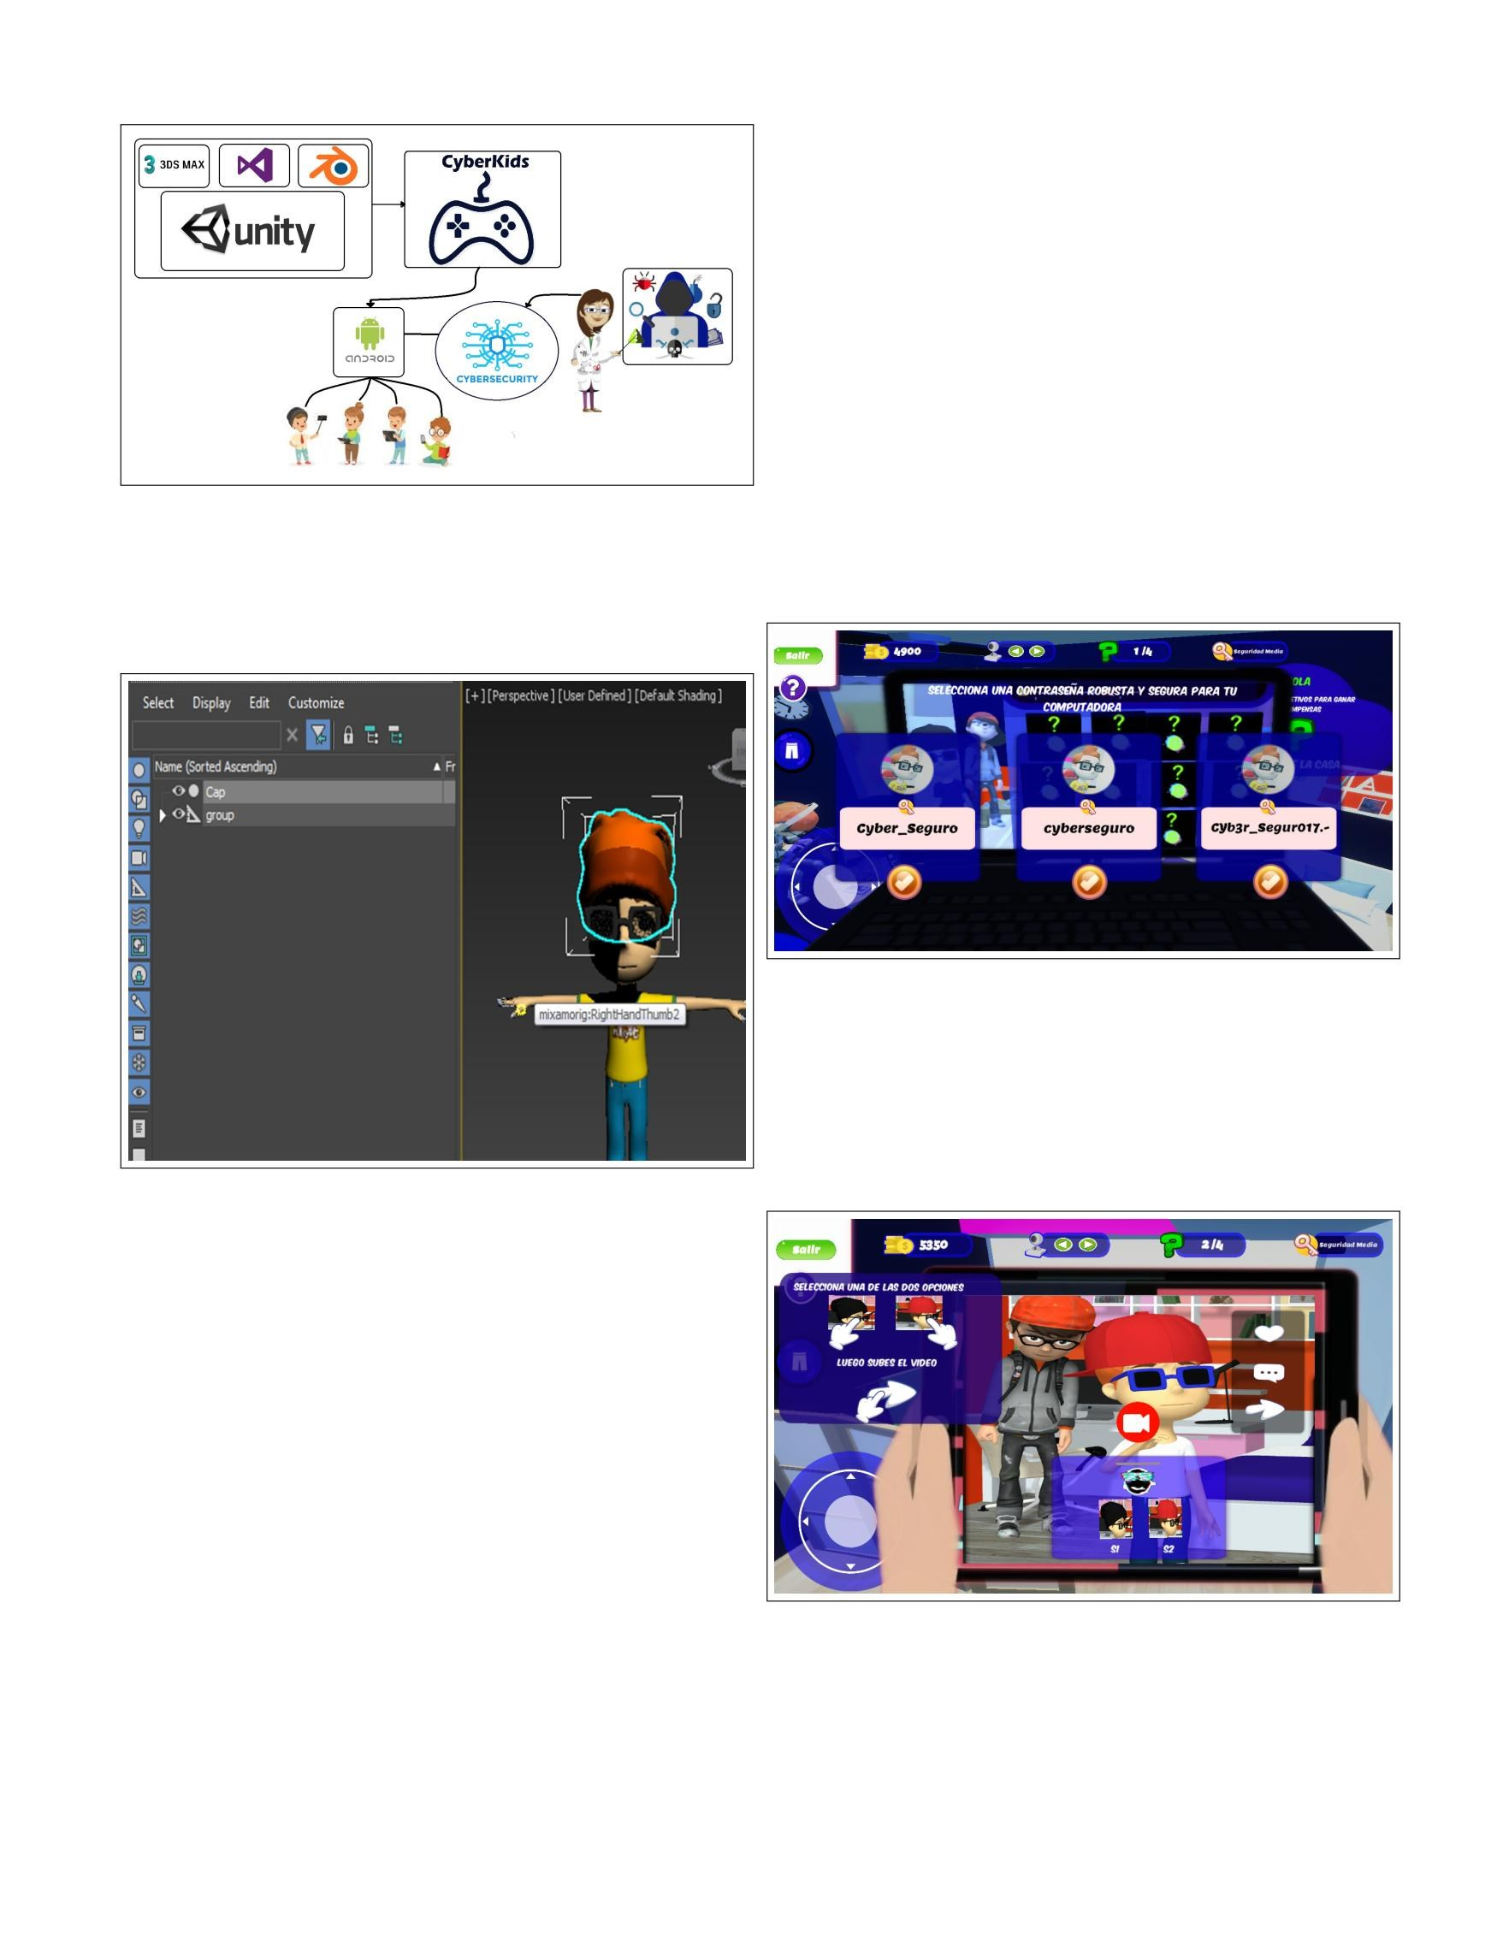
Machine Translated by Google

functionalities which are mainly focused on
educate on the same topic, but in different ways. ´
• Creation of Character Items: Tools such as Blender14 and 3ds Max15 were used
to add ˜
´
some customization items for the avatar. In Fig. 2 we can see how an element is
integrated into the
main character, so that they were made
the necessary settings to export the item to your
respective format to be imported into Unity16
´
In Section III you can see the icons being used to appreciate the amount of score
obtained; amount of
goals achieved; elements such as buttons that meet
´ ´ ´
certain function when pressing them; practical aid capsules; among others.
´ Fig. 1. Scheme of Proposed Solution

III. RESULTS ´
fun way a world which will be traversed by a modifiable character.

´ ˜ Fig. 3. Objective on security through strong passwords

In Fig. 3 you can see the game objective “identify and select strong passwords for a ˜
device”.
´
The user has the option to select between a natural password ˜
a low security password, a medium security password, and a high security password. ˜

Fig. 2. Complement a character with an item in 3DS MAX

In Fig. 2 you can see how in 3ds Max13 it is adjusted ˜
a small element tailored to the main character of CyberKids, thus allowing this element
to be integrated
´ ´
easily in the options of modifying a character within the game.

• Gameplay: Gameplay consists of interacting both
with the scenarios as interface. Users can
´
Create your character who will be introduced in the different scenarios to go
through them, look for objectives and solve them, earning the expected score. ´
The user will go to
´ ˜
encountering small minigames as we can see in Fig. 8.

• User Interface: The user interface is quite

simple, and it has a minimum number of icons,
´

´ ´
Fig. 4. Simulation of interaction on social networks

since the main focus is on the graphics and gameplay. The game is considered

to have multiple

13https://www.autodesk.com/products/3ds-max/overview
´
14https://www.blender.org/
15https://www.autodesk.com/products/3ds-max/overview
16https://unity.com/es

Authorized licensed use limited to: University of Prince Edward Island. Downloaded on May 31,2021 at 14:26:17 UTC from IEEE Xplore. Restrictions apply.
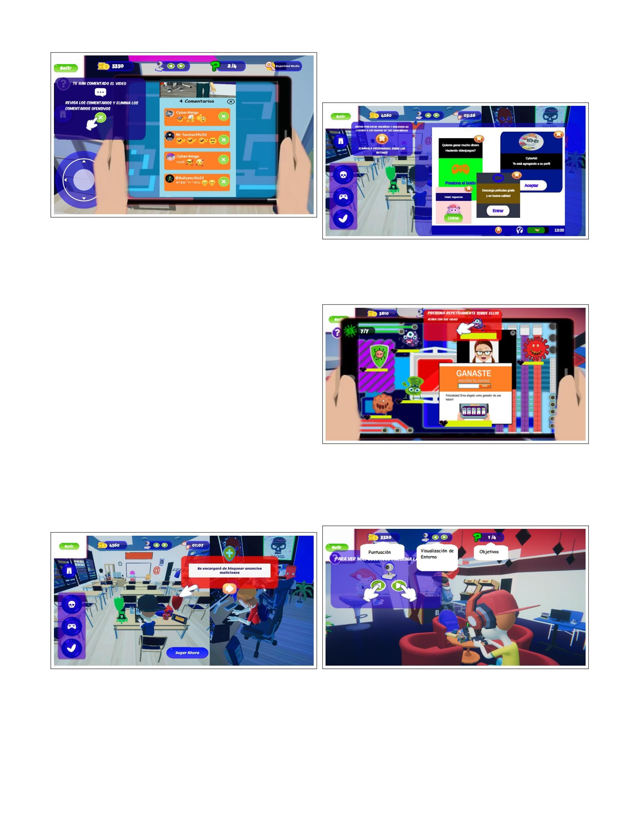
Machine Translated by Google
18
´ ´

of protective shields against massive attacks caused by
19 cybercriminals who want to obtain the private data of the
students. In Fig. 7 you can see some ads

Fig. 5. Simulation of interaction on social networks - comments

Fig. 7. Use of Protective Shields - Malicious Ads ´
Figures Fig. 4 and Fig. 5 show how the user is put to the test and will have to make

´
decisions with quick feedback - winning or losing points.
´ malicious which are activated because of the different attacks

´
In Fig.
´ 17 4 you can see a small simulation of Tik Tok where the player must be able to interact ,
with some
mass received.

´ ´
basic options such as sharing a video through your device. If the player is not able to
recognize some of
´ ´ ´
With these basic options, you will have some help capsules that will allow you to quickly ´ ´
advance your objective. In Fig. 5 you can see a list of comments published in a

video from a Tik Tok account and the player must be able to
to identify some of the malicious comments
´
made by unknown users through this little na˜ simulation ´

Some game levels aim to raise awareness
´
on the importance of protecting personal data in the face of any open vulnerability or any
massive attack
coming from unsafe locations or directions. To make ´
more awareness on the subject, CyberKids allows ´
players interact with a more complex level as can be seen in Fig. 6 and Fig. 7. In Fig. 6

Fig. 6. Use of Protective Shields - Tutorial

can appreciate a level of play which consists of making use

17https://www.tiktok.com/es/
18https://www.tiktok.com/es/

Fig. 8. Mini game

˜
In Fig. 8 you can see a small game which consists of eliminating some malicious ´
elements through repeated keystrokes.

Fig. 9. ´Icons and Main Elements I

Fig. 9 and Fig. 10 show the level at which the ´
player interacts with an animated and eye-catching environment.

19https://www.osi.es/es/campanas/los-cybercriminals-who-are

Authorized licensed use limited to: University of Prince Edward Island. Downloaded on May 31,2021 at 14:26:17 UTC from IEEE Xplore. Restrictions apply.
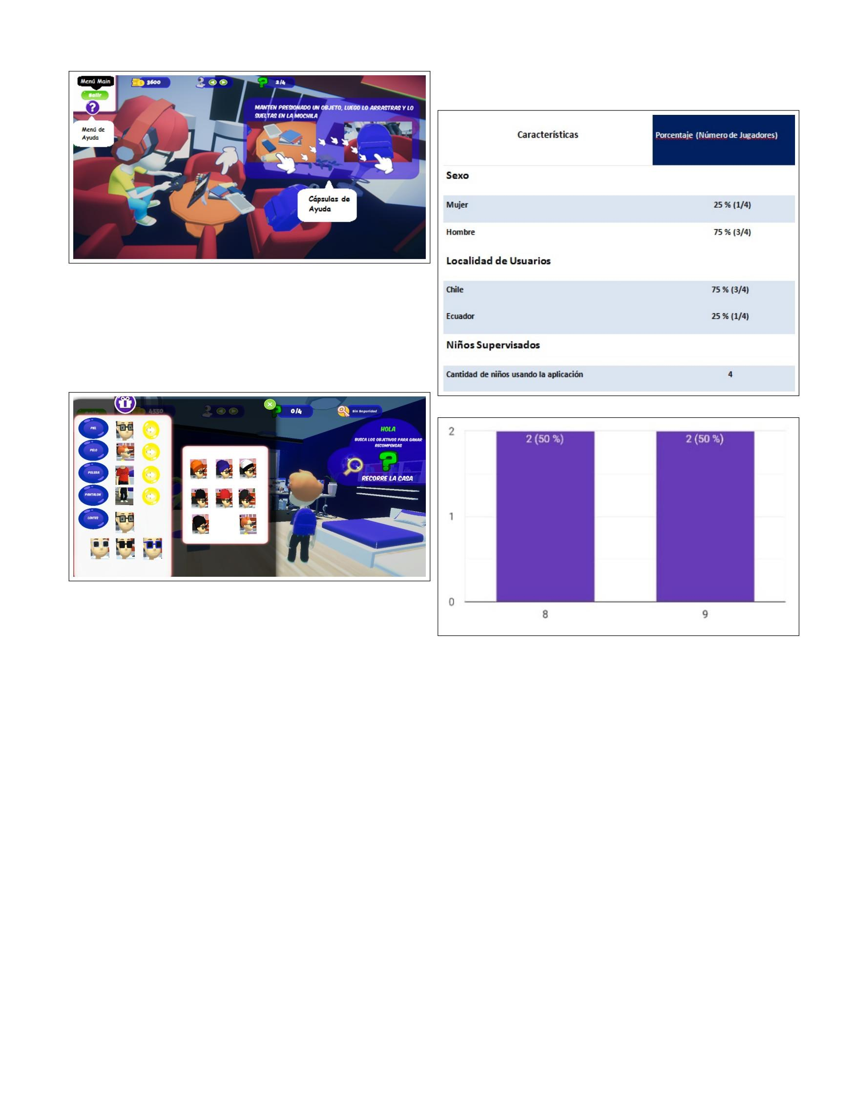
Machine Translated by Google
´
´
˜ ˜

TABLE I
BASIC CHARACTERISTICS OF USERS

Fig. 10. ´Icons and Main Elements II

Like any game, the player can modify his character at any game level as we can see in Fig. 11.

Fig. 11. Customize an Avatar

IV. DISCUSSION ´ OF THE RESULTS

´ ´
The validation presented in this work is incipient but it is a work in progress.
To measure the impact of
product with respect to the expected learning, we have worked with ˜
a very small sample of volunteers, fathers or mothers of children in the age range of 8 and 12 to us.
Table I shows the number of users
´ supervisors and target users who used the application.
Regarding the gaming experience, the users who supervised the gameplay considered that the product in general
is a good experience for target users (Children ˜ ˜
from 8 to 12 years), qualifying the product from a scale of 1 to 10, where 1 is
a bad experience and 10 is
´ a good experience. You can see the rating in Fig. 12

Table II shows the number of comments
and recommendations on possible improvements to consider within the product in general, making it clear that the
product can be improved based on the needs of
Players.
Fig. 12. Rating Scale´

An evaluation form was designed 20 of the product ´
to evaluate the expected learning that allowed to evaluate the following
aspects:

• The ease of entering the different levels of play • Learning about the importance of personal data
chosen

• Learning about the use of social networks • Learning about sharing and caring for
the integrity of personal data
˜
• Learning about the use of patterns and passwords robust security
• The difficulty in general and the ability that the objective users to overcome challenges
• The ability of target users to recognize the educational content delivered

• The ability of targeted users to recognize malicious elements

20https://tinyurl.com/yy9gcgf3

Authorized licensed use limited to: University of Prince Edward Island. Downloaded on May 31,2021 at 14:26:17 UTC from IEEE Xplore. Restrictions apply.
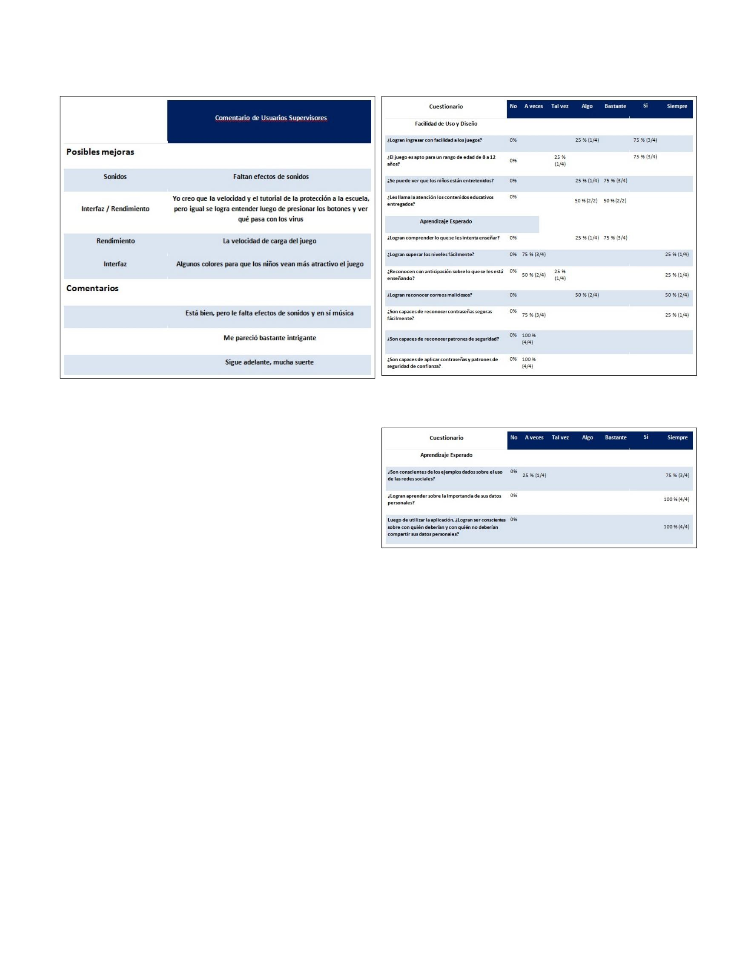
Machine Translated by Google
us.
˜
˜

TABLE II
COMMENTS AND RECOMMENDATIONS

• The ability of target users to recognize patterns and strong security passwords • The ability of target users
to recognize
cer each delivered content
• The ability of target users to recognize the educational
content delivered
• The quality of the content delivered, so that
be eye-catching to target users
• The quality of the challenges, design, atmosphere, music, etc, so that the target users are able to
keep busy and entertained during the experience.

In table III and table IV important results can be seen for the continuous
improvement of the game with respect to ˜
to the ease of use, the design and the expected learning of the product, considering that until now all the
users manage to learn as much about the importance of
personal data as can be seen in Fig. 13, as well as
´ ´ as they also manage to be aware of with whom they should
and with whom they should not share your personal data such as can be seen in Fig. 14 In addition, it can .
be seen that the ease of use and the ˜ CyberKids design allows most users to
can easily access the different levels of play;
´ Allows users to be entertained using the application; It allows it to be striking in
terms of educational content and it is also considered to be a totally suitable ´
game for a child in an age range of 8 to 12 years. Regarding the expected ˜ ˜
learning, according to the supervisory users, the objective users ( children from ´
8 to 12 years old) ˜
˜
TABLE III EXPECTED RESULTS

TABLE IV EXPECTED RESULTS 2

great progress in the different levels; They manage to recognize
some malicious emails; They become aware of the use of social networks; They fully achieve
learning about the importance of your personal data; They manage to be fully aware of the correct
sharing of your personal data.
˜
• They are rarely able to recognize strong passwords; few
sometimes they manage to recognize security patterns; few ˜
Sometimes they are able to apply passwords and security patterns based ´
on what they have learned;
• Sometimes they manage to be able to recognize in advance´ about the delivered content;

V. RELATED WORK

There are many other solutions on the market [7], the
which were studied and analyzed as for example
Hackers vs CyberCrook 21, which is a game that combines ´
fun and learning in matters related to the

obtained the following results:
˜
• They manage to understand about the teaching delivered;

21https://www.osi.es/es/actualidad/blog/2017/12/27/ It hackers-vs-cybercrook-a-fun-game-that-will-test-your

Authorized licensed use limited to: University of Prince Edward Island. Downloaded on May 31,2021 at 14:26:17 UTC from IEEE Xplore. Restrictions apply.
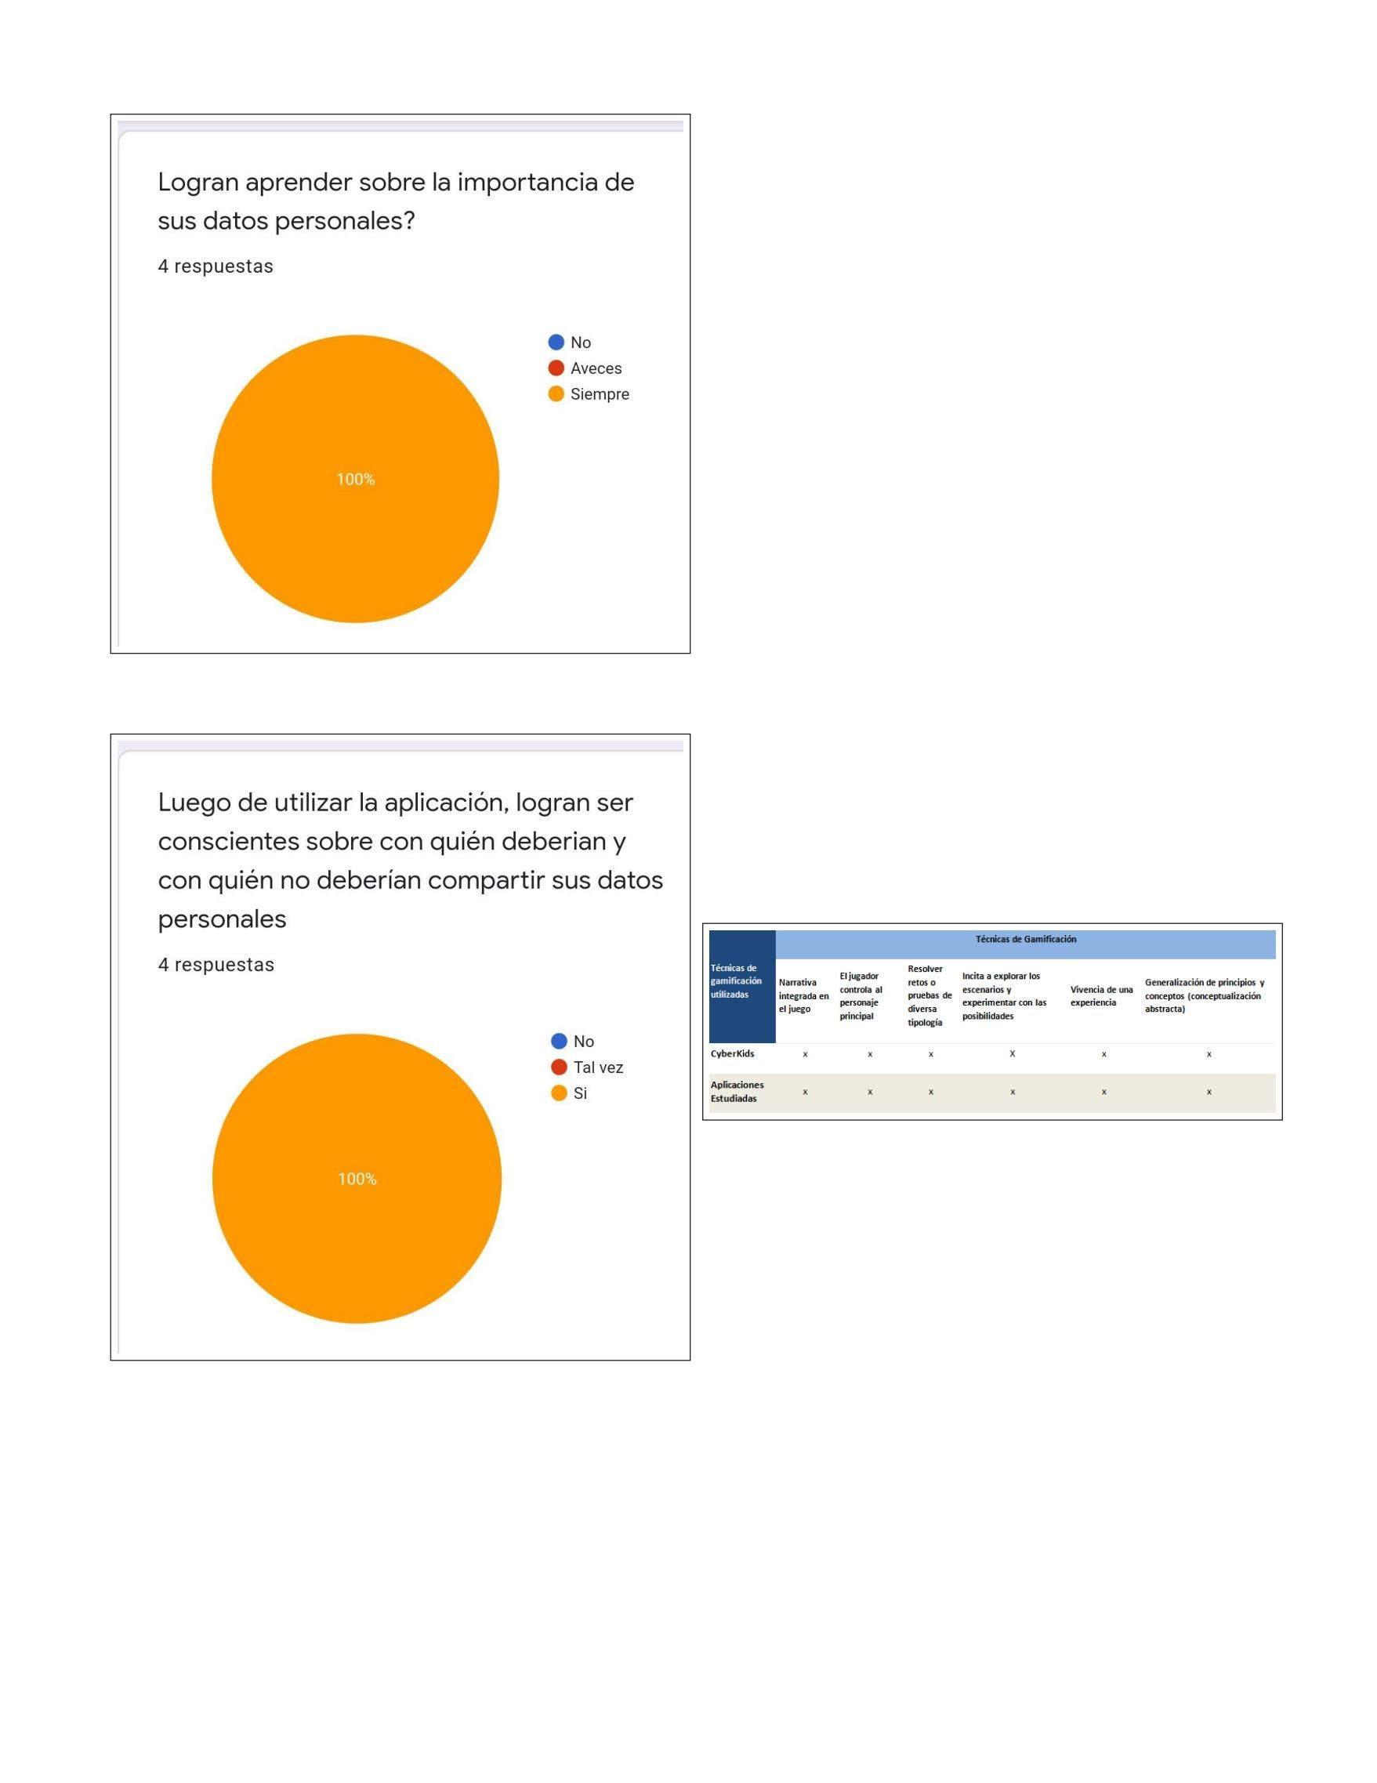
Machine Translated by Google
´
´ ´
24

´
CyberKids gameplay is simpler and more harmonious. ´ ´
In addition, CyberKids is not related to highly complex objectives, providing an adequate
environment for ˜
children and pre-adolescents.
´
Hackend is another similar application for all ages, 22, where the user must control his
character to
identify some cybersecurity gaps in the company
the one that belongs.
Hacking Hero – Cyber Adventure Clicker 23, a game that allows the user to interact with malicious elements which
They must be removed with a click. ´ Similar to CyberKids,

both try to educate about cybersecurity issues and both
they use the click to rule out vulnerabilities. ´
CyberScouts also turns out to be another game very similar to CyberKids, where it is
possible to make a variety of
´ ´
of knowledge tests through multiple objectives integrated into a small experience which tries ˜
to deliver educational information on cybersecurity, but in a fun and playful way. Both games ´
share messages, advice and results at the end of each objective, so that ´

´
Fig. 13. Learning about the importance of personal data both meet the objective of educating through their content.

These are examples of existing applications in the
market, but unlike CyberKids, they are going to integrate ´ ´ ´
multiple methods that will allow addressing important issues based on studies carried out on
experiences lived in the
today, so that the studies carried out are capable of
to be integrated, thus allowing variety in terms of
gaming experience.

Fig. 15. Similarities of CyberKids with the Applications Studied

Fig. 14. Learning about personal data sharing

cybersecurity where a character must protect his house
of cybercrook attacks and to prevent these attacks ´
the character will go on different missions. The relationship
thing CyberCrook has with CyberKids is that both games
SAW. CONCLUSION´ AND FUTURE WORK

´
Despite having an incipient validation, we believe that the results are encouraging
because they allow us to visualize that
CyberKids is a video game that allows learning
of a relevant topic such as cybersecurity in an environment
playful Clearly, this lack of interaction with end users has made it difficult to quickly achieve a ´
final product through an iterative, scrum-like approach, for example. In the

future it is expected to be able to use the application to train ˜
children and pre-adolescents with the respective permissions of the ethics committee. This will allow´ to solve the greater risk of the project´ allowing to adapt the product quickly to
´

22https://www.incibe.es/protege-tu-empresa/hackend

test knowledge and in both games you have
´
control of a character, but the only difference is that

23https://hacking-hero.es.aptoide.com/app
24https://www.is4k.es/de-utilidad/cyberscouts

Authorized licensed use limited to: University of Prince Edward Island. Downloaded on May 31,2021 at 14:26:17 UTC from IEEE Xplore. Restrictions apply.

Machine Translated by Google
˜

maximize the achievement of learning outcomes while the kids are having fun.

THANKS

The work of Romina Torres was partially supported by the internal project UNAB DI-02-19/R.
REFERENCES

[1] B. P. Bergeron, Developing serious games. Charles River Media, 2006.
[2] J.-N. Tioh, M. Mina, and D. W. Jacobson, “Cyber security training a survey of serious games in cyber security,”
in 2017 IEEE Frontiers in Education Conference (FIE). IEEE, 2017, pp. 1–5.
[3] G. Jin, M. Tu, T.-H. Kim, J. Heffron, and J. White,
“Evaluation of game-based learning in cybersecurity edu cation for high school students,” Journal of Education and
Learning (EduLearn), vol. 12, no. 1, pp. 150–158, 2018. [4] W. A. Hill Jr, M. Fanuel, X. Yuan, J. Zhang, and S. Sajad,
“A survey of serious games for cybersecurity education and training,” 2020.
[5] M. Coenraad, A. Pellicone, DJ Ketelhut, M. Cukier,
J. Plane, and D. Weintrop, “Experiencing cybersecurity one game at a time: A systematic review of cybersecurity digital games,” Simulation & Gaming, vol. 51, no. 5, pp. 586–611, 2020.
[6] P. Lee, J.; Ceyhan, “Greenify: A real-world action game for climate change education,” 2012. [Online].
Available: http://tcgameslab.org/wp-content/uploads/2013/ 02/Lee-et-al.-Greenify-Simulationand-Gaming-2013.pdf
[7] Eduka2, “Cybersecurity for children.” ˜ to [Online]. Available: http://eduka2.es/
cybersecurity-for-kids-some-educational-games/

Authorized licensed use limited to: University of Prince Edward Island. Downloaded on May 31,2021 at 14:26:17 UTC from IEEE Xplore. Restrictions apply.

